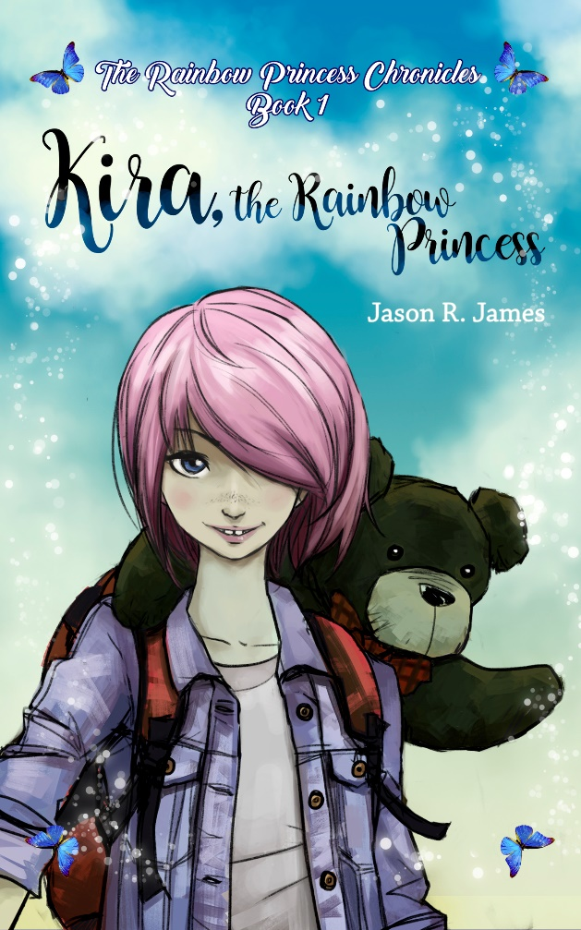

“Jason R. James’ conversational delivery along with his personable style kept ninety spirited sixth-graders focused for almost three hours! He more than delivered on author’s craft, purpose, and literary elements with honesty and humble responses to all of our questions.” – Stefanie Collum, ELA Teacher

“Kira the Rainbow Princess was just what my class needed this year! It created a renewed excitement for reading and an increased desire to write for my fourth-grade students. Mr. James is an exceptional author who not only brought my students’ imaginations to life through the reading of his story, but also in his willingness to dialogue with my students about the “behind the scenes” writing of his book.” – Elizabeth Jackson, Fourth-Grade Teacher

Contact: www.jasonrjames.com

Availabe for Classroom/School Visits to Discuss *Kira the Rainbow Princess* and the Writing Process.

ABOUT THE BOOK: Kira Turner is a typical fifth-grade girl with one major exception— her hair is colored bright pink!

That’s why all the other kids in her class make fun of her and call her “Kira the Weird”. And that used to be her biggest problem… until now.

When Kira gets home from school she discovers that her mother is missing, her house is a wreck, and two strangers are waiting for her at the door.

Now Kira is off on an adventure to rescue her mom with the help of a talking teddy bear, a boy who claims he’s a knight, and a not-so-scary zombie.

Together they’ll learn that it takes much more than magic and swords to save the day!

*Kira the Rainbow Princess* is a middle-grade fantasy adventure novel suitable for students in 3rd through 6th grade.

Local Author and English Teacher

Jason R. James